LAB 5

Fork processes:

* child and parent
* FORK function -> fork()

A=0

Skeleton for every c function:

If pid==0:

Child

Else

Parent

Int pid =

fork()

child

parent



A++

Return 0

Wait(0)

Exit(0)



!! child -> exit(0) ; parent -> wait(0) => always in pair

* Simple main program in c

* Using fork function in main

* Example using pid

!!! LICENTA -> receive diagram and have to write a c program that will replicate the process using fork

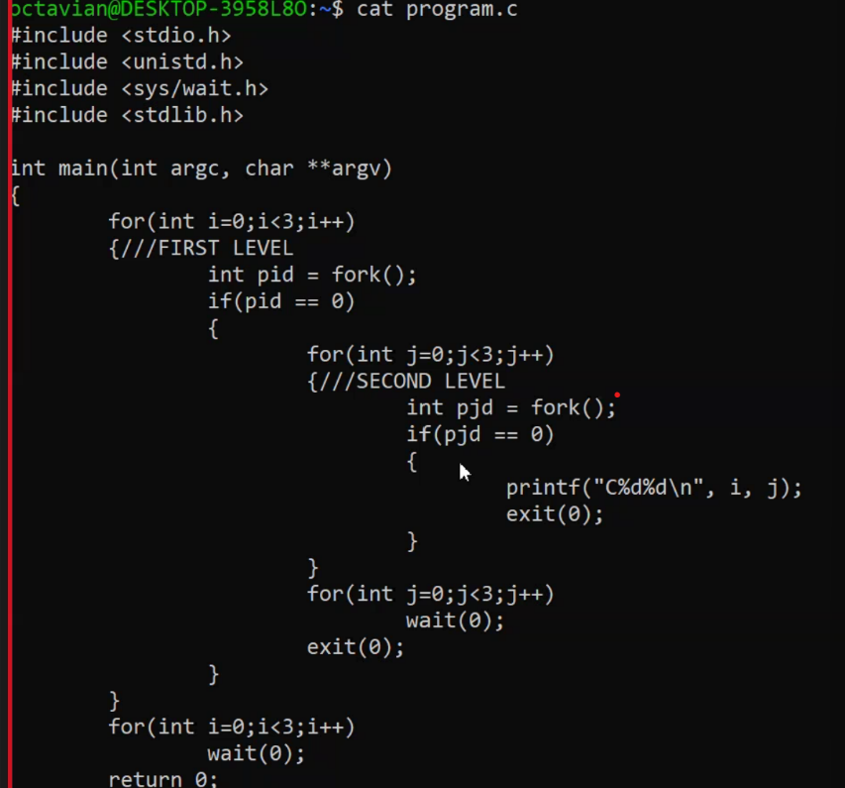

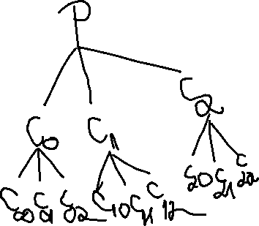

FUNCTION: execlp(command_to_execute, rest_of_array….,NULL)

Eg. Grep -E “word” a.txt

execlp(“grep”,”grep”,”-E”,”word”,”a.txt”,NULL)

The first grep is a file path.

Whenever execlp is executed, replaces the whole execution with its own. It is used in child processes.

